We are excited to welcome your children into our faith formation programming. Our program is designed to help your children develop a lifelong relationship with Jesus. We are dedicated in providing a safe and nurturing environment where they can discover and grow.

Going to church every Sunday provides each of us, and our family with a strong Christian foundation with which to build their life upon. This comes from hearing the Word of God, and how much God loves us. We build our parish community by coming to Mass and praying with others each weekend.

All students’ family’s must be active registered parishioners of St. John’s. For further information on parish registration contact Cathy Williamson at 201-664-3131 ext. 110

**Information on Faith Formation Programs**

● The **Summer Program** is an intensive course of catechesis for grades 1 through 8 that is taught in a span of 5 consecutive days during a week of June 23. Additionally, classes once a month during the academic year are on Sunday morning for students and faith formation for parents.

* + Classes during the week of June 23 begin at 8:30am and go on to 12:00pm
  + Sunday return classes once a month during the academic year – dates TBD
  + Return classes begins at 8:45am and goes on to 9:45am in St. John’s academy classrooms.
  + Attendance is required for all classes.
  + Parents monthly faith formation in the parish center on the same morning as the children are in class from 9:00am to 9:40am (only one parent needs to attend) during the academic year
* **Sunday Weekly Program** instruction is offered in academy classrooms for grades 1 through 8. Classes begin in mid-September 2025 and go on to March 2026.
  + **NEW – Jr. High 7th and 8th grade class will be offered during the Sunday Weekly program**
  + Sunday’s classes begin at 8:45am and go on to 9:45am
  + Parents gather for a monthly Faith Formation in the parish center one Sunday morning a month from 9:00am to 9:40am (only one parent must attend) during the same time their child(ren) are in class.
  + Attendance is required for all faith formation classes.
* **Home Program** is for children in grades 1 through 6**.** This at home model from Loyola Press, the parent or guardian is the primary instructor for catechesis.  The children are offered a model of catechesis that embraces technology, individualized learning on a semi flexible schedule and shares an on the ongoing invitation to enter a deeper relationship with Jesus and encourages them to find Jesus in all things.
  + Children are to attend a monthly faith formation on a weekday evening with at least one parent
  + Formation begins at 7:00pm and concludes at 8:00pm in the parish center

*Page 1 of 4*

* **Home Program** (continued)
  + Children attend faith formation in a classroom setting and parents attend a faith formation in the community room.
  + Two opportunities are offered each month.
  + Sign Up Genius sends each parent an invitation each month to sign their child(ren) up for the formation.
  + Interactive online work that is to be submitted on a timely basis is reviewed on a timely basis
* **Junior High Program is for children entering Grades 7and 8.** The model of this program is to experience catechesis both in classroom and at home instruction.
  + **NEW OPTION –** Sunday Weekly in the academy 8:45am to 9:45am (see Sunday Weekly Program)
  + Jr. High Home program children are to attend a monthly formation on a weekday evening
  + Jr. High Program begins at 7:00pm to 8:00pm for both students and parents.
  + Catechists will teach 2 of the 6 chapters in class and continue to read the four chapters at home with the workpaper. Workpapers are collected before each class begins.
  + Parent faith formation will be at the same time as their child has class.

​The themed books for this year are The Church, Sacraments and Morality from the program*Alive in Christ*by Our Sunday Visitors. The initial parent meeting will be in September. Date & time TBD.

**Faith Formation Volunteer Positions**

The Faith Formation Programs at St. John’s requires the assistance of numerous volunteers to work effectively. The various positions that volunteers fill is described below:

Catechist is a person of faith who leads the class of students to help them develop a deeper understanding of the doctrine of the Catholic faith. A catechist manual and curriculum guideline is provided as are support gatherings throughout the year.

A Co-Catechist are two people of faith who share leading the class of students to help them develop a deeper understanding of the doctrine of the Catholic faith. A catechist manual and curriculum guideline is provided for each person as are support gatherings throughout the year.

A Classroom Aide helps the catechist in the classroom with various responsibilities.

Registration fees on the next page.

*Page of 2 of 4*

**Faith Formation Catechist/Co-Catechist Registration Fee:**

The role of a Catholic Catechist is to catechize the Faith of the Catholic Church, both by word and example. A Catechist is someone who lets the word of God echo through their life. A Catechist shares their faith and guides their students to learn how to apply and live their faith

**Summer or Sunday Weekly program Catechist Payment (Grades 1 to 8)**

One Child - $90.00 Two Children - $180.00

Three or more Children - $250.00

**Co-Catechist Payment Grades 1 to 8)**

One Child - $160.00 Two Children - $300.00

Three or more Children - $400.00

**Home Program Catechist (Grades 1 to 8)**

One Child - $160.00 Two Children - $300.00

Three or more Children - $400.00

**Jr. High Home Program Catechist (Grades 7 and 8)**

One Child - $160.00 Two Children - $300.00

Three or more Children - $400.00

**Faith Formation Registration Fee:**

One Child - $230 Two children - $380 Three or more children - $480

Page 3 of 4

***St. John the Baptist Church***

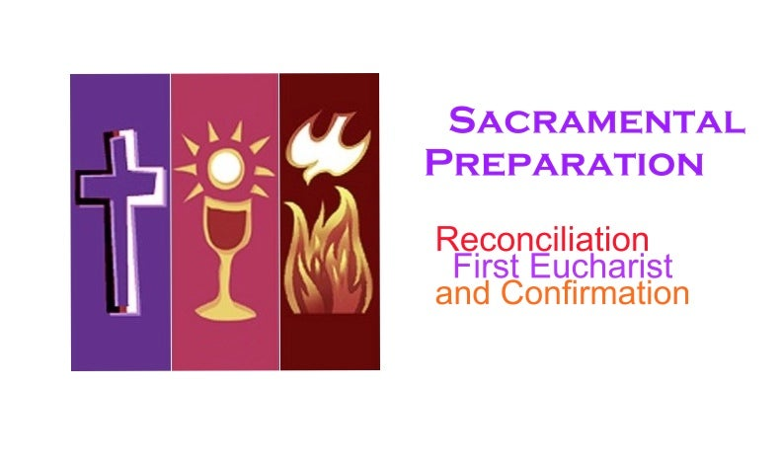

**First Reconciliation and First Communion** is offered to children of our parish in

the second grade or older who have been baptized in catholic church. Parish

community families who currently have a child(ren) registered in St. John’s Faith Formation

(aka CCD) or St. John Academy and entering 2nd grade or higher in September 2025 can register. The initial parent meeting will be in October 2025.

**Confirmation is a two-year preparation program** for youth in high school grades.

Candidates have time for discernment, and formation as they seek to follow Christ as one of His disciples. The two-year program includes information meetings to guide the candidates on their journey, 4 sessions each year (total of 8), 15 hours of service, retreat time, and two

events. Facilitators, sponsors, and families work with the church community to

assist and empower the candidates as they give witnesses to their faith in words,

and action by using their gifts to live out their Christian vocation.

Parish community families who have a son or daughter entering 9th grade or higher in September can register online. The initial incoming candidate and parent meeting to be determined.

Page 4 of 4